TSDS Key, Secret, and URL Assignment

The following steps are for LEA personnel responsible for configuring the district’s Individual Operational Data Store (IODS) data permissions and security authorization within the Data Management Center (DMC) application. The role and access to this process should be limited to one or two individuals only.

- Log into TEAL.
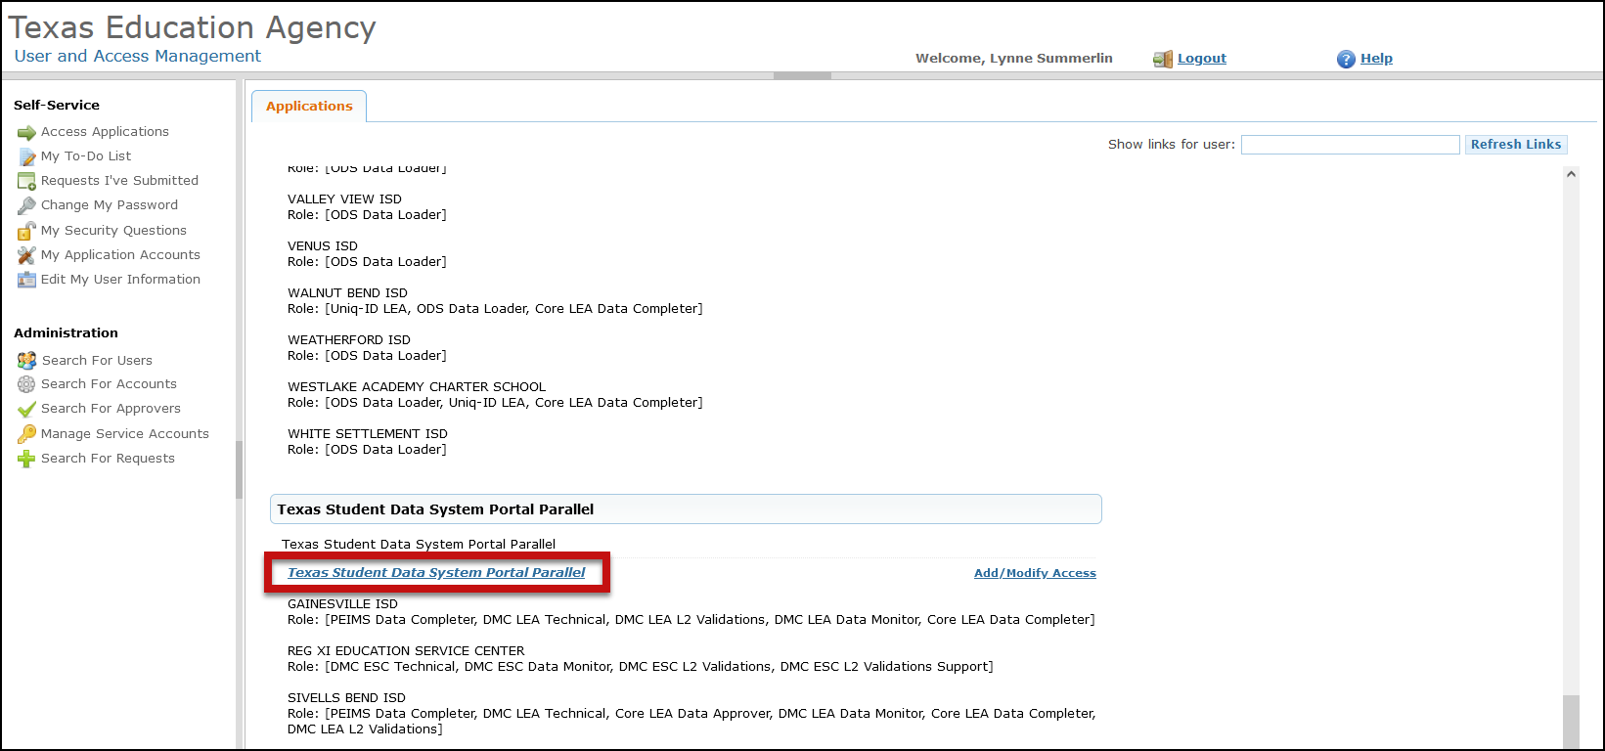
- Click on Texas Student Data System Portal Parallel link.

- Click on Manage IODS.
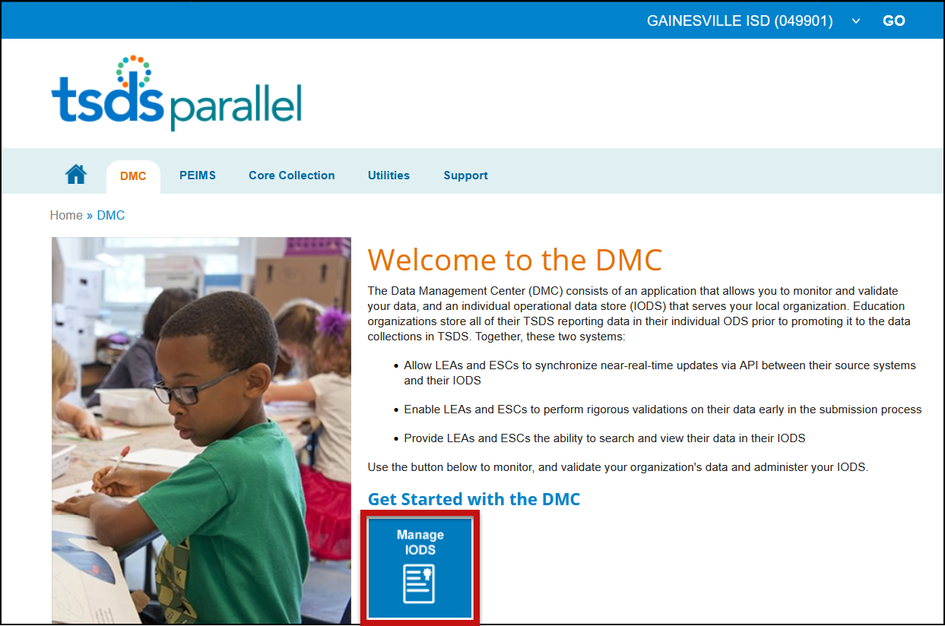

- On the Data Management Center (DMC) screen select Admin > Manage Application, Keys, and Secrets.

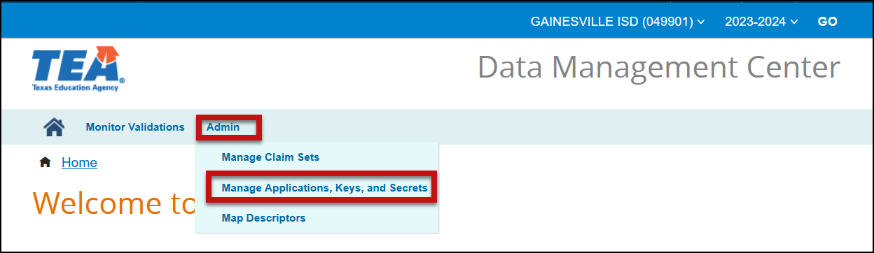

- Select Add Application.

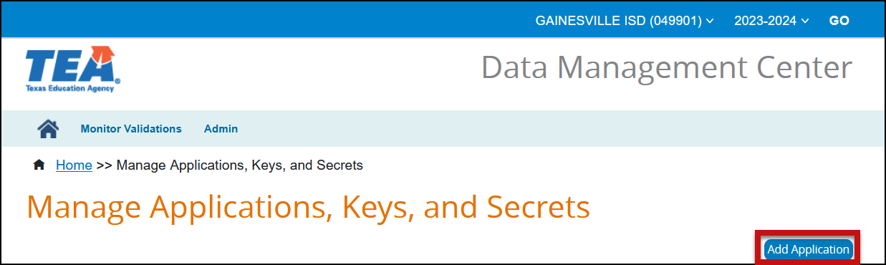

- Enter an Application Name. It is suggested to enter the Vendor Name and Application (ASCENDER Student/Business).
- Select the appropriate Claim Set Name from the pull-down menu. A separate Claim Set must be assigned if district uses a different vendor for either student, finance, human resources, or assessments.

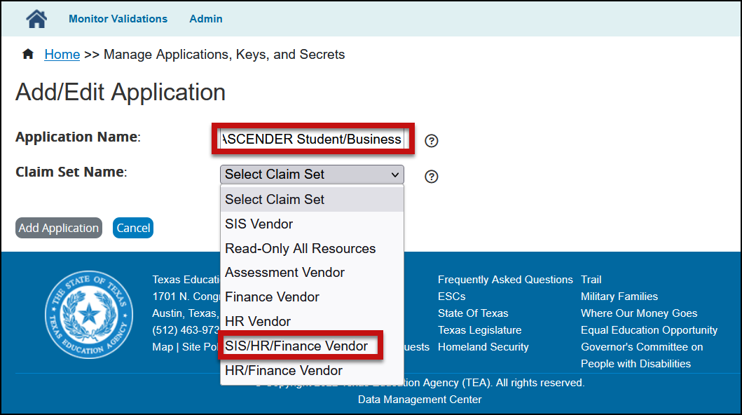

- Click Add Application.
- Click Save to save the application.
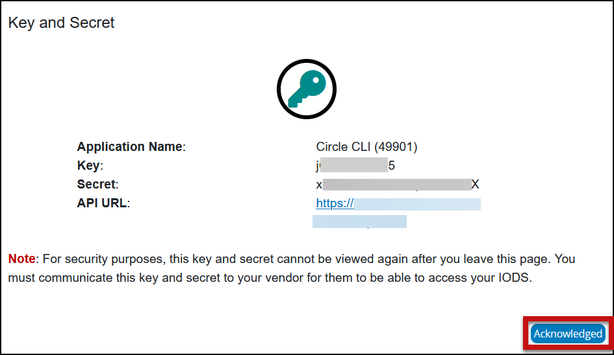
- A Key, Secret, and API URL will be created. Copy and paste the key, secret, and URL in the appropriate area in your database(s) or to a text document. DO NOT click Acknowledged until you have copied and pasted the information!

- Click Acknowledged.
- Repeat the previous steps 4-11 to add additional Claim Sets.

